SagaWere (VR Gaming Controller)

Final Year Project

Session 2022

A project submitted in partial fulfillment of the degree of

BS in Computer Science


Department of Computer Science
Faculty of Computer Science & Information Technology
The Superior University, Lahore

Spring 2023

Type (Nature of project) |  |  | [ ] Development [] Research [] R&D
Area of specialization |  |  | Virtual Reality / Gaming
FYP ID |  |  | FYP-F22-046
Project Group Members
Sr.# | Reg. # | Student Name |  | Email ID | *Signature
(i) | BCSM-F19-349 | ZOHAIB RAFIQUE |  | BCSM-F19-349@superior.edu.pk
(ii) | BCSM-F19-365 | MUHAMMAD IRFAN |  | BCSM-F19-365@superior.edu.pk
(iii) | BCSM-F19-335 | HUZAIFA TARIQ |  | BCSM-F19-335@superior.edu.pk

*The candidates confirm that the work submitted is their own and appropriate credit has been given where reference has been made to work of others

Plagiarism Free Certificate
This is to certify that, I ZOHAIB RAFIQUE S/D of Muhammad RAFIQUE, group leader of FYP under registration FYP-046 at COMPUTER SCIENCE Department, The Superior College, Lahore. I declare that my FYP report is checked by my supervisor.

Date: Name of Group Leader: ZOHAIB RAFIQUE Signature: _____________
Name of Supervisor: M. SALEEM MUSTAFA Co-Supervisor:
Designation: Lecturer Designation: Associate Professor
Signature: ________________ Signature: _________________

HOD: Dr. Irfan Ud Din
Signature: _______________

SagaWere – The VR Gaming Controller

Change Record
Author(s) | Version | Date | Notes | Supervisor’s Signature
Zohaib Rafique | 1.0 | 01-01-2023 | Compiled Chapters
Muhammad Irfan | 2.0 | 02-02-2023 | Compiled Chapters
Huzaifa Tariq | 3.0 | 15-03-2023 | Compiled Chapters
Zohaib Rafique | 3.1 | 15-05-2023 | Compiled Chapters
Sagawere Team | 4.0 | 02-06-2023 | Compiled Chapters

APPROVAL
Project Supervisor
Comments: ___________________________________________________________________
_____________________________________________________________________________
Name:______________________________
Date:_______________________________ | Signature:__________________________

Project Manager
Comments: ___________________________________________________________________
_____________________________________________________________________________
Date:_______________________________ | Signature:__________________________

Head of the Department
Comments: ___________________________________________________________________
_____________________________________________________________________________
Date:_______________________________ | Signature:__________________________

Acknowledgements
I would like to express my deepest gratitude to my supervisor, Mr. Saleem Mustafa, for his invaluable guidance and support throughout the duration of my Final Year Project (FYP). His expertise, patience, and dedication have been instrumental in shaping the successful completion of this project.
I am truly grateful to Mr. Saleem Mustafa for providing me with a platform to explore and enhance my skills in this field. His insightful feedback, constructive criticism, and continuous encouragement have significantly contributed to the improvement and development of my project.
I would also like to extend my appreciation to the faculty members and staff of Superior University for their constant support and resources made available to me during this project. Their willingness to assist and provide valuable insights have greatly enriched my learning experience.
Furthermore, I would like to thank my family and friends for their unwavering support and encouragement throughout this journey. Their belief in my abilities and their continuous motivation have been a driving force behind my determination to excel in this project.
Lastly, I would like to express my gratitude to all the individuals who willingly participated in the surveys, interviews, or any other data collection methods required for this project. Their cooperation and contribution have been invaluable in ensuring the success and accuracy of the results.

Executive Summary
Sagawere is a desktop application used by Pc gamers for playing games with virtual triggers/controllers through your hand motion and body gestures. You can download virtual triggers or controllers for different games on our platform. New controllers for new games uploaded on Sagawere timely. Our user can easily download any triggers for playing game (i.e., Pubg, Need for Speed). Our platform also provides virtual mouse and virtual keyboard for users. Users can easily download and operator computer virtually. Most of the game controllers are free to use but some of the controllers are paid. We are providing subscription plans for accessing all controllers for all type of games.
Sagawere is an optical hand and body tracking Software (Desktop Application) that captures the movement of users’ hands and fingers so they can interact naturally with digital content. Small, fast, and accurate, the Sagawere virtual Controller can be used for productivity applications with Windows computers, integrated into enterprise grade hardware solutions or displays, or attached to virtual/augmented reality headsets for AR/VR/XR prototyping, research, and development. As Sagawere software used for playing games with your hand gesture and body motion. Gaming experience will change with our technology. Our software has ability to play all games and able to move virtual avatar in metaverse.
Scope of this technology is defined with the scope of gaming. This software can easily be configured with any game and make games more enjoyable. This technology is unique. We have no competitors in our field. Gaming Trend is increasing day by day and gamers will find a new trend of game playing with our software.
Developers for the Sagawere gathered an incredible amount of data regarding motion-capture of actual moving things in real-life scenarios. Processing all of this data using a special artificial intelligence machine-learning algorithm allows the Sagawere to map the visual data it collects to models representing people of different backgrounds (age, height, gender, body type, clothing and more).
Sagawere work with built in laptop or Pc webcams, but RGB cameras are preferable for its efficient functionality and accuracy of body detection.

Table of Contents
SagaWere (VR Gaming Controller) i
Final Year Project i
Session 2022 i
BS in Computer Science i
*The candidates confirmations ii
Plagiarism Free Certificate ii
Acknowledgements v
Executive Summary vi
Table of Contents vii
List of Figures ix
List of Tables ix
Chapter 1 1
Introduction 1
1.1. Background 2
1.2. Motivations and Challenges 2
1.3. Goals and Objectives 2
1.4. Literature Review/Existing Solutions 2
1.5. Proposed Solution 3
1.6. Project Plan 3
1.6.1. Work Breakdown Structure 3
1.6.2. Roles & Responsibility Matrix 4
1.6.3. Gantt Chart 4
1.7. Empathy Map 5
Chapter 2 7
Software Requirement Specifications 7
2.1. Introduction 8
2.1.1. Purpose 8
2.1.2. Product Scope 9
2.1.3. References 10
2.2. Overall Description 10
2.2.1. Product Perspective 10
2.2.2. Operating Environment 10
2.2.3. Design and Implementation Constraints 11
2.3. External Interface Requirements 12
2.3.1. User Interfaces 12
2.3.2. Hardware Interfaces 12
2.3.3. Usability Requirements 13
2.3.4. Reliability Requirements 14
2.3.5. Maintainability/Supportability Requirements 15
2.3.6. Portability Requirements 15
2.3.7. Efficiency Requirements 16
Chapter 3 18
Use Case Analysis 18
3.1. Use Case Model 19
3.2. Use Cases Description 20
Chapter 4 21
System Design 21
4.1. Architecture Diagram 22
4.2. Domain Model 23
4.3. Entity Relationship Diagram with data dictionary 24
4.4. Class Diagram 25
4.5. Sequence / Collaboration Diagram 26
4.6. Operation contracts 26
4.7. Activity Diagram 27
4.8. State Transition Diagram 27
4.9. Component Diagram 28
Component diagram showing the tracking policy and communication with 3dUIs using virtual devices interfaces. 28
4.10. Deployment Diagram 29
4.11. Data Flow diagram 29
Chapter 5 30
Implementation 30
5.1. Important Flow Control/Pseudo codes 31
5.2. Components, Libraries, Web Services and stubs 32
5.3. Deployment Environment 32
5.3. Tools and Techniques 33
5.4. Best Practices / Coding Standards 34
5.5 Version Control 35
Chapter 6 36
Testing and Evaluation 36
6.1. Use Case Testing 37
6.2. Equivalence partitioning 38
6.3. Boundary value analysis 38
6.4. Data flow testing 38
6.5. Unit testing 39
6.6. Integration testing 39
6.7. Performance testing 39
6.8. Stress Testing 40
Chapter 7 41
Summary, Conclusion and Future Enhancements 41
7.1. Project Summary 42
7.2. Achievements and Improvements 42
7.3. Critical Review 44
7.4. Lessons Learnt 46
7.5. Future Enhancements/Recommendations 47

List of Figures

1.1 Caption of first figure of first chapter 6
1.2 Caption of second figure of first chapter 7
2.1 Caption of first figure of second chapter 14
2.2 Caption of second figure of second chapter 22
2.3 Caption of third figure of second chapter 26
5.1 Caption of first figure of fifth chapter 49
5.2 Caption of second figure of fifth chapter 49

List of Tables

1.1 label of first table of first chapter 6
1.2 label of second table of first chapter 7
2.1 label of first table of second chapter 14
2.2 label of second table of second chapter 22
2.3 label of third table of second chapter 26
5.1 label of first table of fifth chapter 49
5.2 label of second table of fifth chapter 49

Chapter 1

Introduction

Chapter 1: Introduction

Background
As we know that gaming trend increases day by day and gamers want reality-based experience. For this purpose, many gaming controllers and triggers are developed to improve gaming experience (i.e., Racing Wheel, Fighting Guns, Sword Triggers), these are all controllers are highly paid.

Motivations and Challenges
Our aim to develop the technology which give new trend of gaming for gaming industry, with the concept of Virtual Reality and Augmented Reality we develop the technology for entering in to game with your physical movement. AR/VR and Metaverse are the emerging fields of the future so we are targeting these technologies.
Our team include all the Skills and requirement related to the Startup.
Unity Developer
Blockchain Developer
AR/VR Expert
Technology Developer
UI/UX Designer

Goals and Objectives
Our goal is to develop a Metaverse based game, and make the player to feel himself in this VR game. Touch sensibility, Smell Sensibility, Locomotion of Virtual avatar are some features which we want to add in Metaverse Technology.
Our vision is to change the trend of gaming we will add features of locomotion in Virtual Reality with help of our device
Gamers will improve their gaming skills with help of this device.
This device provides enjoyable gaming experience for gamers.

Literature Review/Existing Solutions
Sagawere is unique because we have no competitor in our field. This technology provides the realistic experience of games which enhance the market of gaming and reduce the market of hardware gaming controllers. Video gamers find new way of playing games with cheapest cost, they do not need to purchase expensive hardware gaming controllers but the soft controllers which have low cost and highest realistic experience.

Proposed Solution
Sagawere eliminate the use of physical gaming triggers and controllers and change the market to virtual triggers/controllers. 50 million gamers buy physical controllers for playing games like Need for Speed, Racing Games, Action Games.
- Gaming become Cheaper: Gaming become cheaper with our product because Sagawere provide virtual controllers for playing games and there is no need to buy physical controllers for playing games.

- Gaming become More Enjoyable: We are playing games for enjoy, Sagawere make games more enjoyable because user feel the reality of games if they play games with their body motion and hand gestures.

- No Device Needed: All the other products related to Sagawere and locomotion in VR required expensive devices i.e., camera or other related devices, but Sagawere used simple webcam of user device for its proper functionality.

- Quality improvement: Quality of gaming will improve with Sagawere, because it provides the realistic view gaming. For example, if we are playing PUBG with Sagawere, players can fire with different body angles detected by Sagawere.

- Higher level of customer service: Level of customer services enhanced.

Project Plan
We secured the investment in developing Sagawere technology and for Marketing purpose. We need the assets to grow this product in gaming industry. We need investment for buying servers, development and related Items.

Work Breakdown Structure
Elapsed time in (days or weeks or month or quarter) since start of the project
1-3 Week Project Information Gathering
4-8 Week Business Analysis
9-12 Week Project Simulation and Designing
13-20 Week Project Implementation
21-24 Week Project Marketing Plans

Roles & Responsibility Matrix
Elapsed time in (days or weeks or month or quarter) since start of the project | Milestone | Deliverable
1-3 Week | Project Information Gathering | Project Proposal with all related information
4-8 Week | Business Analysis | Business Plan of Project
9-12 Week | Project Simulation and Designing | Project Prototype and Project Simulation
13-20 Week | Project Implementation | Designed Project with proper functionalities
21-24 Week | Project Marketing Plans | Design Marketing Strategy

Gantt Chart
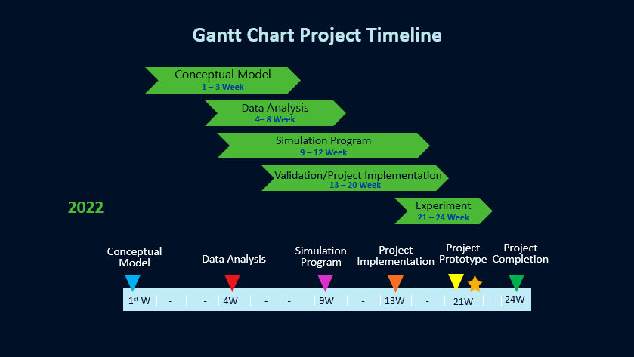

Empathy Map

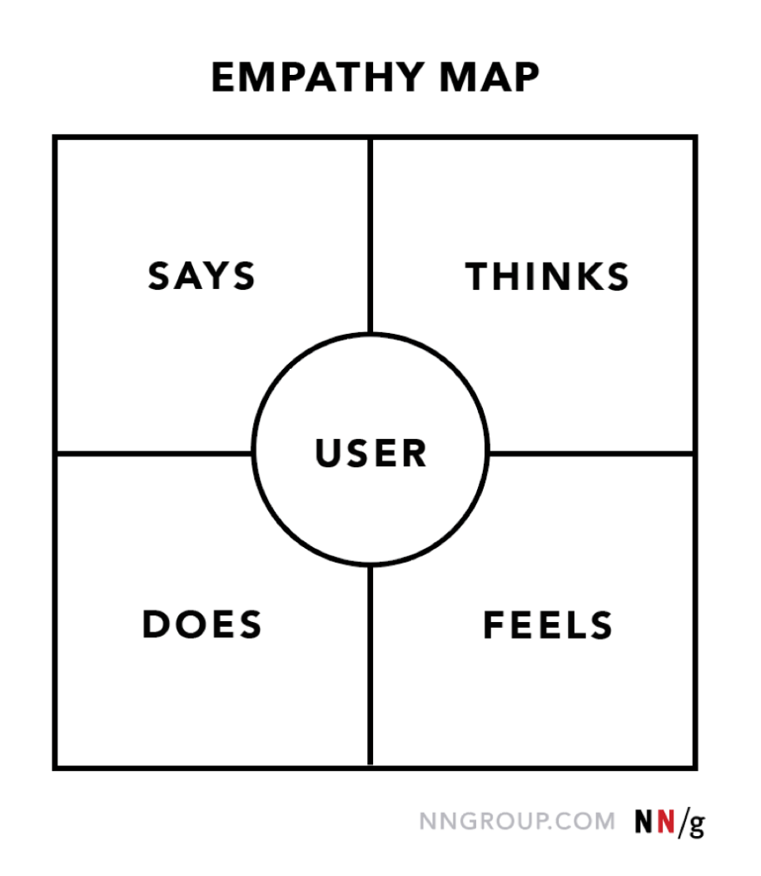

- Says
Most of the customers question us that how we can feel the virtual reality?
So, our aim is to provide full body feel in virtual reality. We calmly reply them that our device which will provide you feel of VR, while playing games your physical appearance coordinate with virtual world.
- Does
Our users will able to feel the virtual reality with our prepared system. As we know that virtual world is going to popular in some couples of years.
- Thinks
Our aim is to develop a system which provide new trend of gaming. User can use own hand and legs for playing games and use as a virtual controller. Different controllers will be available for different games

- Feels
We feel that Gaming and virtual reality and Metaverse become most popular thing in this planet after some years, So, we can feel that our project idea is beneficial among all others technologies.

Chapter 2

Software Requirement Specifications

Chapter 2: Software Requirement Specifications

Introduction

Purpose
By implementing Sagawere, gaming become cheaper and more enjoyable. There are 102.61 million PC gamers in Pakistan and out of these 102.61 million, 66 million gamers pay for game for more enjoying it. We are targeting in this customer segments.
Sagawere eliminate the use of physical gaming triggers and controllers and change the market to virtual triggers/controllers. 50 million gamers buy physical controllers for playing games like Need for Speed, Racing Games, Action Games.
- Gaming become Cheaper: Gaming become cheaper with our product because Sagawere provide virtual controllers for playing games and there is no need to buy physical controllers for playing games.
- Gaming become More Enjoyable: We are playing games for enjoy, Sagawere make games more enjoyable because user feel the reality of games if they play games with their body motion and hand gestures.
- No Device Needed: All the other products related to Sagawere and locomotion in VR required expensive devices i.e., camera or other related devices, but Sagawere used simple webcam of user device for its proper functionality.
- Quality improvement: Quality of gaming will improve with Sagawere, because it provides the realistic view gaming. For example, if we are playing PUBG with Sagawere, players can fire with different body angles detected by Sagawere.
- Higher level of customer service: Level of customer services enhanced because Sagawere served even that type of customers who are not able to but expensive controllers.
- Increased customer retention rate: Subscription of gaming controllers is very low. Some of the gaming controllers are free to use but some of that are paid. We provide different subscription plan for customers that increase customers retention rate.

- Production cost reduction: Production cost of virtual gaming controllers is very low that decrease the subscription of our software and increase the customer retention rate.

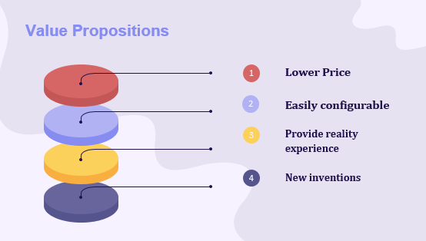

Product Scope
Sagawere is a desktop application used by video gamers for playing games with virtual triggers through your hand and body gestures. You can download virtual triggers for different games on our platform. Some of the triggers are paid but mostly triggers are free to use.

- Playing Game using virtual triggers or controllers
- Gamers can improve his experience of gaming and feel the reality.
- In Pakistan there are about 102 million gamers and 55 million PC gamers we are targeting to about 55 million gamers at startup and can reached Gamers internationally which is about 2.9 billion.
- It is Desktop base application which can be easily downloadable from our website(https://sagawere.blogspot.com)
- User can download controllers for different games and start to play games virtually.
- This software can configure easily with any game according to requirements (Simple Webcam or RGB Camera sis required)
- User can choose the default triggers according to its experience.
- Sagawere include virtual mouse and keyboard, user can easily download mouse and keyboard and start to operate the device virtually.
- Physical gadgets and controllers will be replaced with our software as we are providing experience of virtual reality in locomotion.
- We are using a simple camera which configured with software and control the gaming triggers with locomotion.

References
https://www.sagawere.com/
sagawere01@gmail.com

Overall Description

Product Perspective
Product Perspective:

Sagawere is a desktop application that offers a unique and innovative gaming experience by allowing PC gamers to play games using virtual triggers/controllers through hand motion and body gestures. The product aims to provide an immersive and intuitive gaming interface that enhances the gameplay experience for users.

From a product perspective, Sagawere can be seen as a standalone software solution designed to bridge the gap between traditional keyboard/mouse controls and motion-based interactions. It serves as a middleware layer that integrates with existing games and provides an alternative control mechanism for gamers.

Operating Environment
The Sagawere Controller is designed for simple integration into customer applications and can be retro-fitted to existing concepts or hardware.
- Plugins for Unity and Unreal enable developers working with two leading 3D development platforms to incorporate hand tracking into their established workflow.
- Our TouchFree application detects a user’s hand in mid-air and converts it to an on-screen cursor, allowing touchscreen interfaces to be retrofitted with touchless gesture control.

Design and Implementation Constraints
During the design and implementation of Sagawere, several constraints should be considered to ensure the successful development and deployment of the application. These constraints can include technical, resource, and compatibility considerations. Here are some key constraints to take into account:
1. Hardware Compatibility: Sagawere's effectiveness relies on integrating with motion tracking devices or technologies. Therefore, a primary constraint is the compatibility of the application with a range of hardware options. It is essential to identify and test compatibility with various motion tracking devices to ensure seamless integration and optimal performance.

2. Software Compatibility: Compatibility with different operating systems (such as Windows, Mac, and Linux) is crucial to reach a wider user base. The design and implementation of Sagawere should consider the specific requirements and dependencies of each target operating system to ensure proper functioning and usability.

3. Performance and Latency: To provide a satisfying gaming experience, Sagawere should minimize latency between the user's gestures and the corresponding in-game actions. The application's design and implementation must prioritize efficiency and responsiveness, ensuring that motion tracking data is processed quickly and accurately to provide real-time interactions.

4. Development Resources: Availability of development resources, including software libraries, motion tracking SDKs, and other necessary tools, may impose constraints during the implementation phase. Adequate research and selection of appropriate development resources are crucial to ensure efficient development and smooth integration.
5. Game Compatibility and Updates: The application's success relies on its compatibility with a wide range of games. However, due to the constant evolution of gaming technologies and updates to games themselves, ensuring compatibility and timely updates for new releases may present implementation constraints. Continuous monitoring and updates will be necessary to keep the repository up-to-date with new game controllers and ensure seamless integration with the latest game versions.

External Interface Requirements

User Interfaces
Sagawere provides desktop user interface and it’s mainly for PC games in starting. Interface is user-friendly, provide user profile details a subscription detail. As mentioned, Sagawere provide different subscription plans for accessing controllers. All the controllers are uploaded to the software, so user can easily download and start to use.

Hardware Interfaces
Our aim to embed this software in hardware device for its better performance. Hardware device contain RGB came to capture the user body and convert its movement to virtual reality.

- Nonfunctional Requirements System Features
Provide Free Gaming Controllers
Provide VR Games
User Friendly Interface
- Software interface
Software interface of sagawere is user-friendly. User can login or signup. If the user does not want to subscribe the provided packages then enjoy the free gaming controllers by simply downloading and starting to control.
- Performance Requirement
Sagawere is an optical hand and body tracking Software (Desktop Application) that captures the movement of users’ hands and fingers so they can interact naturally with digital content. Small, fast, and accurate, the Sagawere virtual Controller can be used for productivity applications with Windows computers, integrated into enterprise grade hardware solutions or displays, or attached to virtual/augmented reality headsets for AR/VR/XR prototyping, research, and development. As Sagawere software used for playing games with your hand gesture and body motion. Gaming experience will change with our technology. Our software has ability to play all games and able to move virtual avatar in metaverse.
- Safety Requirements
Sagawere provide safety, playing games can damage the human eyesight and without any physical activity gamers feels the physical issues day by day. As the sagawere provide physical VR controllers, so gamers feel the game with unharm their physical health.

Usability Requirements
Usability Requirements:

1. Intuitive User Interface: Sagawere should have a user-friendly and intuitive interface that is easy to navigate, ensuring a smooth user experience. The interface should be designed with clear and concise labels, menus, and controls to minimize user confusion and facilitate efficient interaction.

2. Clear Instructions and Help: The application should provide clear instructions and guidance on how to use the software, download controllers, and perform other essential tasks. Help documentation, tooltips, and contextual hints can assist users in understanding the functionality and features of Sagawere.

3. Responsive and Real-Time Interactions: The application should provide real-time response to users' hand motions and body gestures, ensuring a seamless and immersive gaming experience. The responsiveness and accuracy of the motion tracking technology should be optimized to minimize any perceptible lag between the user's movements and the in-game actions.

4. Compatibility with Game Genres: Sagawere should be designed to support a wide range of game genres, including action, racing, adventure, and more. The application should provide intuitive and appropriate virtual triggers/controllers for each game genre, enabling users to enjoy diverse gaming experiences.

5. Customization and Personalization: The application should allow users to customize their gaming experience according to their preferences. This may include options to adjust sensitivity settings, button mapping, and gesture recognition to suit individual gaming styles and needs.

Reliability Requirements

1. Stable Performance: Sagawere should deliver stable and consistent performance throughout the user's gaming sessions. The application should minimize crashes, freezes, or unexpected shutdowns, ensuring reliable operation without significant disruptions.

2. Data Integrity: The application should ensure the integrity of user data, such as user profiles, subscription details, and controller preferences. Sagawere should implement appropriate data backup and recovery mechanisms to prevent data loss and maintain the reliability of user information.

3. Compatibility with Games: Sagawere should maintain compatibility with a wide range of games to provide reliable control options for different titles. Regular updates should be provided to support new game releases, ensuring that users can rely on the application to work seamlessly with their favorite games.

4. Robust Motion Tracking: The motion tracking functionality of Sagawere should be robust and accurate, consistently capturing and interpreting the user's hand motions and body gestures. The system should have minimal sensitivity to external factors (e.g., lighting conditions) and should be able to adapt to varying user movements reliably.

5. Error Recovery: In the event of any unexpected errors or issues, Sagawere should be designed to recover gracefully. The application should provide clear error messages and instructions for users to troubleshoot problems effectively. Additionally, the system should have built-in mechanisms to recover from errors automatically whenever possible, minimizing user frustration and maintaining the reliability of the overall experience.

Maintainability/Supportability Requirements

1. Modular and Extensible Design: Sagawere should be designed with modularity and extensibility in mind. The application's architecture and codebase should be organized into modular components, allowing for easier maintenance and future enhancements. This design approach enables developers to add new features, update existing functionality, and address bugs or issues efficiently.

2. Documentation and Knowledge Transfer: Comprehensive documentation should be provided for Sagawere, including installation guides, user manuals, and developer documentation. This documentation should cover the system's architecture, configuration, APIs, and any relevant development guidelines. Well-documented code and comments within the source code can also aid in maintaining and supporting the application over time.

3. Version Control and Release Management: Utilizing version control systems, such as Git, along with appropriate branching strategies and release management practices, can facilitate efficient collaboration among the development team. This approach enables easy tracking of changes, simplifies code review processes, and allows for controlled deployments of updates and bug fixes.

Portability Requirements

1. Cross-Platform Compatibility: Sagawere should be designed to be compatible with multiple operating systems, such as Windows, Mac, and Linux. This ensures that the application can be easily installed and used on different platforms, allowing a wider user base to access and enjoy the software.

2. Hardware Independence: The application should aim for hardware independence, meaning it should not be tied to specific hardware devices or configurations. By abstracting hardware dependencies, Sagawere can be deployed on various systems without requiring modifications or additional setup steps specific to different hardware setups.

3. Ease of Installation and Deployment: Sagawere should have a streamlined installation and deployment process to maximize portability. The installation package should be packaged in a way that simplifies the setup and configuration steps for users, minimizing the need for manual intervention or complex system configurations. This enables users to install and deploy Sagawere quickly and easily on different systems.

Efficiency Requirements
Portability Requirements:

Efficiency Requirements:

1. Real-Time Performance: Sagawere should prioritize real-time performance to ensure seamless and responsive interactions between the user's hand motions and body gestures and the corresponding in-game actions. The application should process and interpret motion tracking data swiftly and accurately, minimizing any noticeable delay or lag.

2. Resource Optimization: Sagawere should strive to optimize resource usage to ensure efficient operation and minimize system resource requirements. This includes optimizing CPU and memory usage, as well as managing power consumption effectively. By utilizing system resources efficiently, the application can provide a smooth gaming experience without excessive strain on the user's device.

3. Bandwidth Efficiency: In scenarios where Sagawere requires online connectivity, such as downloading game controllers or accessing subscription services, the application should aim to be bandwidth-efficient. Data transfers should be optimized to minimize the amount of data transmitted, reducing network latency and ensuring a smooth and responsive user experience, particularly for users with limited or unstable internet connections.

4. Responsiveness to Configuration Changes: Sagawere should be able to adapt to changes in system configurations or settings efficiently. This includes adjusting to different screen resolutions, input devices, or performance profiles of the user's device. The application should automatically detect and adapt to these changes to ensure optimal performance and usability.

5. Quick Startup and Load Times: Sagawere should have fast startup and load times to provide users with a seamless and prompt experience. The application should minimize the time required to launch and load game controllers, allowing users to begin playing games quickly and reducing any potential frustration associated with long waiting times.

Chapter 3

Use Case Analysis

Chapter 3: Use Case Analysis
Sagawere is an optical hand and body tracking Software (Desktop Application) that captures the movement of users’ hands and fingers so they can interact naturally with digital content.
As technology and experience have advanced, artificial intelligence has provided virtual characters with the ability to respond more realistically. 3-D audio and improved haptic feedback and devices also contribute to a much more immersive experience. Other improvements have expanded delivery options beyond tethered machines and headsets to mobile devices and smartphones.
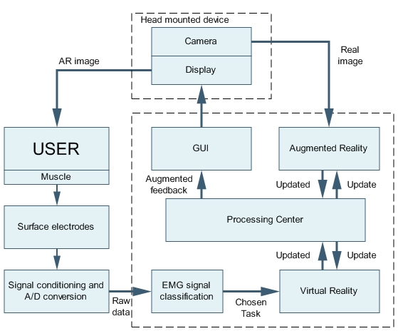

Use Case Model
[Paragraph Text 12 pt, Calibri, 1.5 Line Spacing, Justified]

Use Cases Description
Virtual reality gaming is the application of an artificial environment to computer games. Virtual reality environments are created with VR software and presented to the user in such a way that they supersede the real-world environment, creating suspension of disbelief and helping the user experience the VR environment as real.
VR gaming control may involve a standard keyboard and mouse, game controllers or motion capture methods. More complex VR rooms may include treadmill floors or similar methods to further the user's sense of freedom of movement and feelings of immersion within the virtual environment.
Developers for the Sagawere gathered an incredible amount of data regarding motion-capture of actual moving things in real-life scenarios. Processing all of this data using a special artificial intelligence machine-learning algorithm allows the Sagawere to map the visual data it collects to models representing people of different backgrounds (age, height, gender, body type, clothing and more).
Sagawere work with built in laptop or Pc webcams, but RGB cameras are preferable for its efficient functionality and accuracy of body detection.

Chapter 4

System Design

Chapter 4: System Design

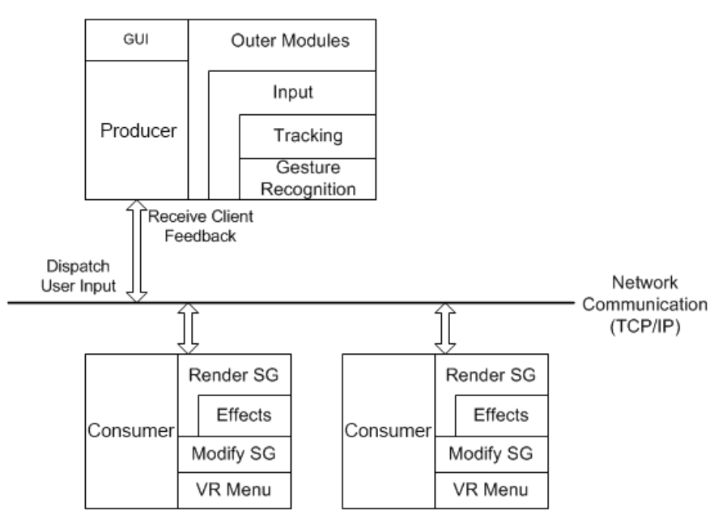

Architecture Diagram
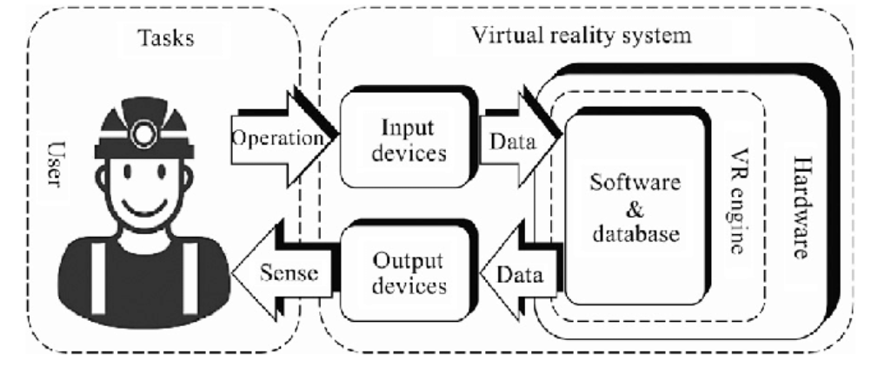

Domain Model

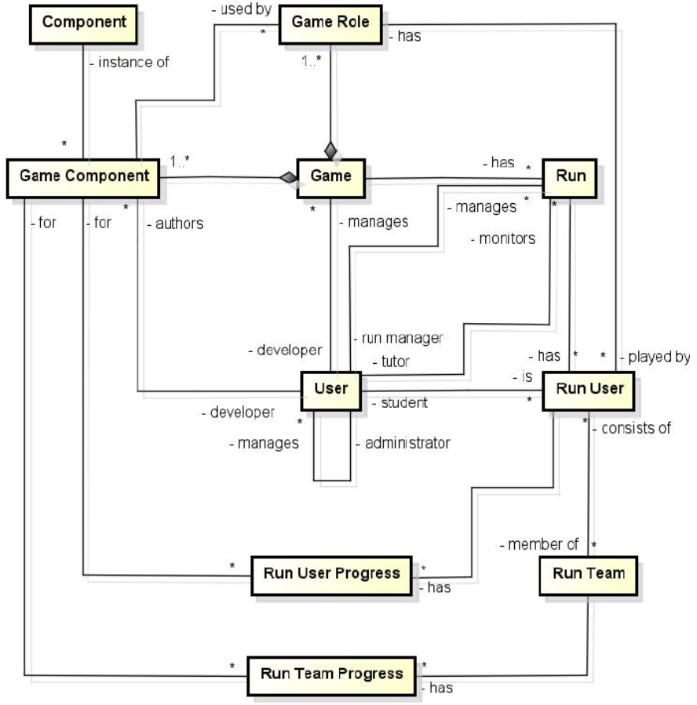

Entity Relationship Diagram with data dictionary
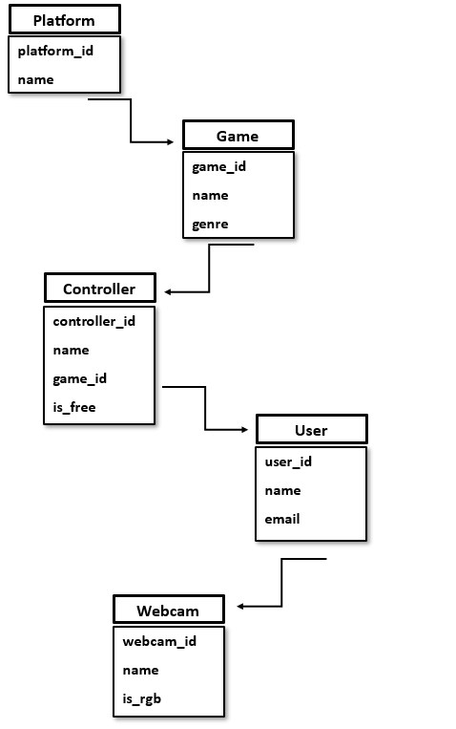

Class Diagram

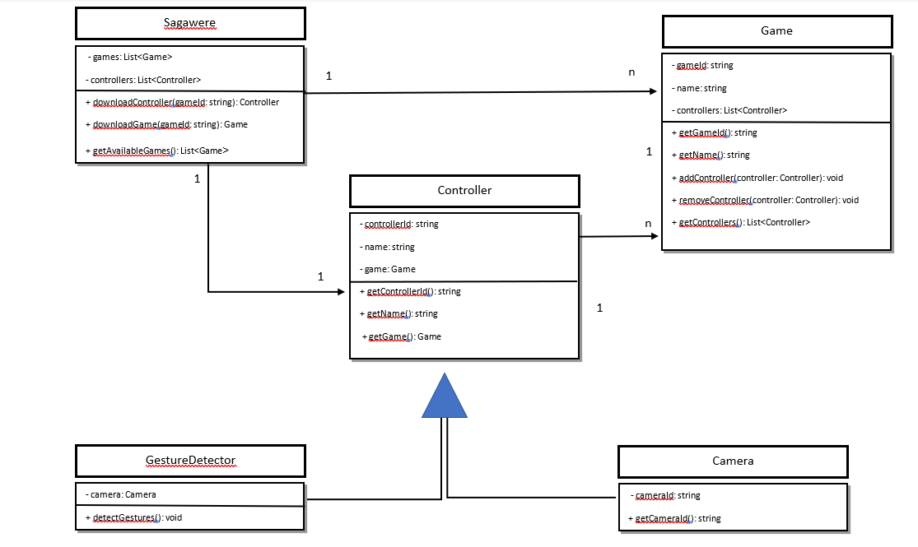

Sequence / Collaboration Diagram
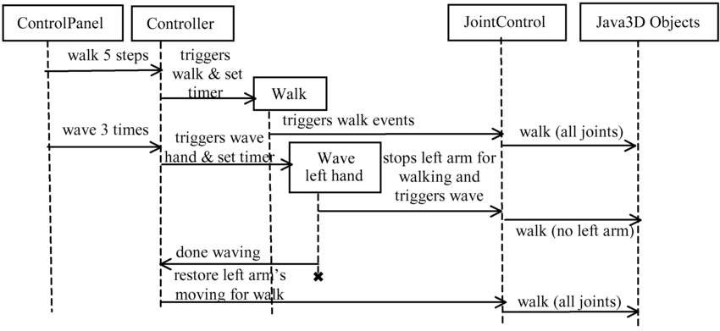

Operation contracts
The Sagawere Controller is designed for simple integration into customer applications and can be retro-fitted to existing concepts or hardware.
- Plugins for Unity and Unreal enable developers working with two leading 3D development platforms to incorporate hand tracking into their established workflow.
- Our TouchFree application detects a user’s hand in mid-air and converts it to an on-screen cursor, allowing touchscreen interfaces to be retrofitted with touchless gesture control.

Activity Diagram
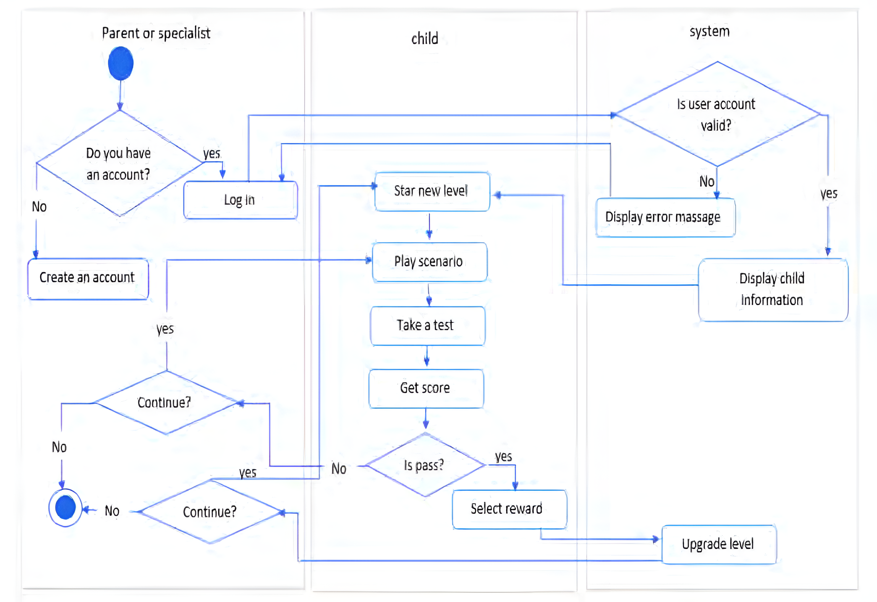

State Transition Diagram
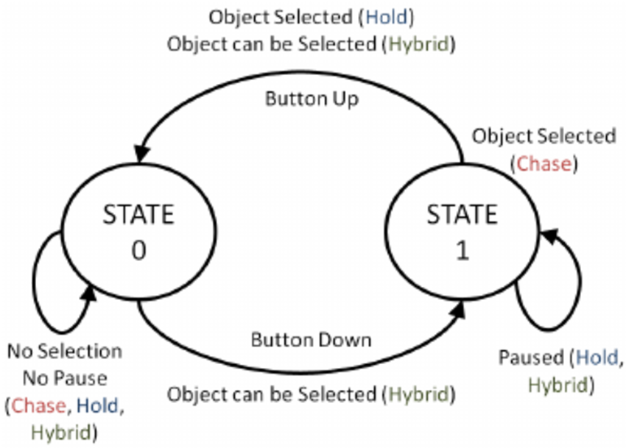

Component Diagram

Component diagram showing the tracking policy and communication with 3dUIs using virtual devices interfaces.
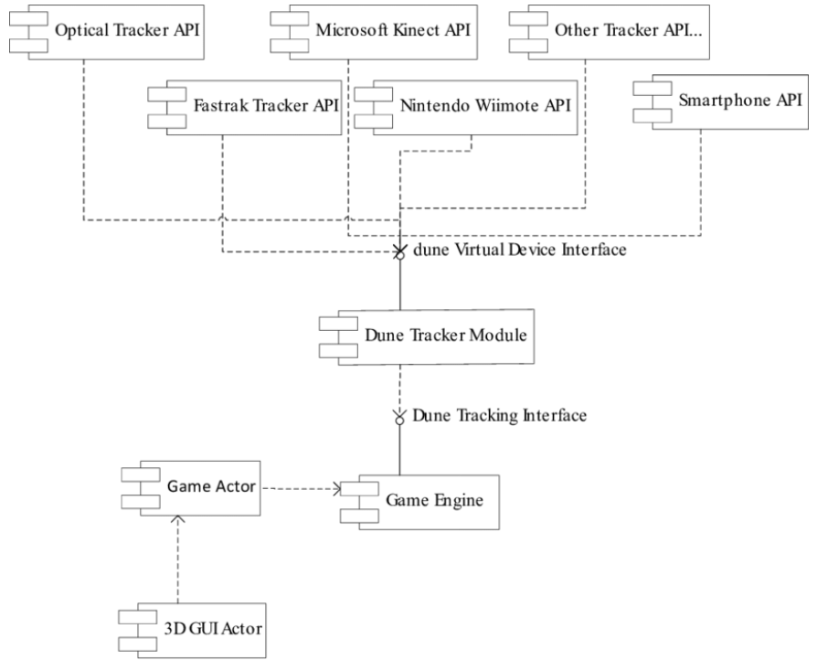

Deployment Diagram
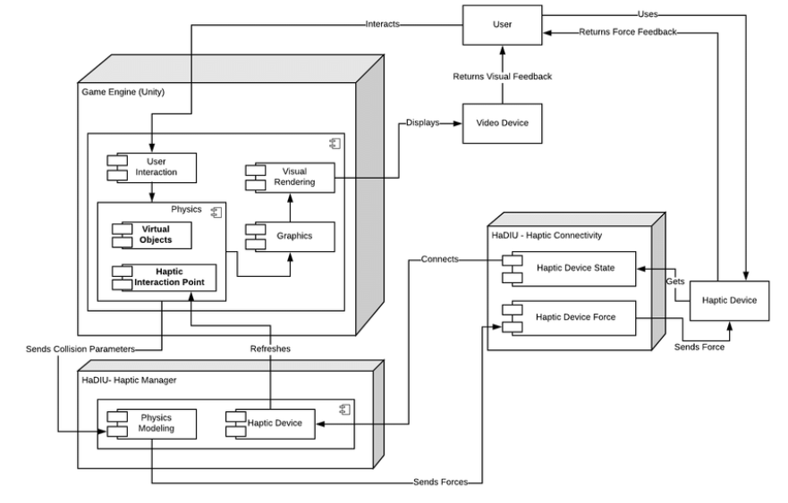

Data Flow diagram
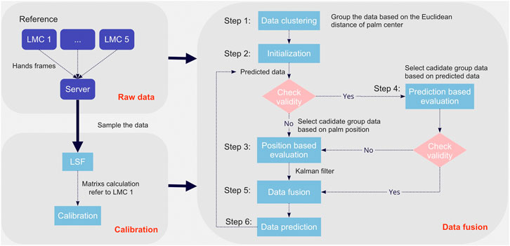

Chapter 5

Implementation

Chapter 5: Implementation
Sagawere is a Desktop Application based on Python Framework. GUI and UI/UX model is developed in python language. Sagawere platform provide files of virtual controllers for playing games of which user can easily download and start for playing different games.
The Virtual triggers are also developed in python language because python provide us platform for capturing camera of user device and by using different libraries. We are able to convert hand gestures and body motion of person into digital content and assemble this information for developing virtual controllers.

Important Flow Control/Pseudo codes
Project is delivered in software form. Team lead divide the project module to Sagawere team. Sagawere divided in to 7 modules.
- GUI of Sagawere
- Python Framework Integration
- Development of Virtual Default Controller i.e., mouse, keyboard etc.
- Development of Action Games Virtual Controllers
- Development of Racing Game Virtual Controllers
- Body Tracking SDK
- Subscription module of Sagawere

Warranty documents: Our product have complete warranty and guidance. Users can get any kind of information get out from documents.
Pictures: For clarity when setting up the project and helping those who will maintain and playing game enjoyable.
As-built drawings: These are drawings to give a blueprint what happened in our product and how to use it.
Test results: To prove that our product have unique product in the uses of gamer and certified to be appropriate for use.

Components, Libraries, Web Services and stubs
Python Libraries:
We are using different libraries for implementation i.e., autopy, numPy, media pipe, python-cv. These python libraries help us to configure player gestures with playing games.
Digital Image Processing:
Digital Image Processing is used for the accurate working of virtual controllers, by using this we are able to point of player body and hand gestures.

5.3. Deployment Environment
The deployment environment for Sagawere, a desktop application developed using Python, involves the following components:
1. Operating System: Sagawere can be deployed on various operating systems, including Windows, Mac, and Linux, as long as the Python framework is supported on the target platform. The application should be tested and verified for compatibility with each specific operating system to ensure smooth operation.

2. Python Framework: Sagawere is built on a Python framework, leveraging the capabilities and libraries provided by the language. The application's codebase should be developed and optimized using Python best practices to ensure efficient execution and compatibility across different Python versions.

3. GUI and UI/UX: The graphical user interface (GUI) and user interface/user experience (UI/UX) components of Sagawere are developed using Python. Python offers a range of libraries and frameworks, such as Tkinter or PyQt, that facilitate the creation of visually appealing and interactive interfaces. The GUI and UI/UX should be designed with a focus on ease of use, intuitiveness, and responsiveness.

4. Virtual Controllers: The virtual controllers provided by Sagawere are developed using Python. The hand gestures and body motions of the user are captured through the device's camera, and Python libraries and algorithms are utilized to process and convert this information into digital content. These virtual controllers are then assembled and made available for download by users.

5. Python Libraries: Sagawere relies on various Python libraries to enable the implementation of motion tracking, image processing, and other functionalities. The deployment environment should ensure that the required Python libraries are properly installed and configured, allowing seamless integration and execution of Sagawere's features.

6. System Requirements: The deployment environment should meet the necessary system requirements to ensure optimal performance of Sagawere. This includes having a compatible operating system version, sufficient processing power, memory, and storage capacity, as well as a camera or webcam for motion tracking.

7. Installation and Configuration: The deployment process involves packaging Sagawere as an installer or executable file, which simplifies the installation and setup for end users. Clear instructions and documentation should be provided to guide users through the installation process and any necessary configurations for the application to function properly.

It is important to note that the specific deployment environment may vary depending on the target platform and requirements of the project. Therefore, careful consideration and testing should be conducted to ensure Sagawere is compatible and performs optimally in the chosen deployment environment.

Tools and Techniques
- Python Framework:
Python framework Django is used for the implementation of Sagawere. Virtual triggers are also developed in python language.

- Artificial Intelligence
Sagawere convert the user device webcam into AI Sensor which sense the body motion and color detection. Artificial intelligence is used to make webcam as AI sensor.
- Python GUI
GUI of Sagawere is developed in python GUI Tkinter. GUI is designed to provide platform for download controller and a start button to start specific controller for use.

5.4. Best Practices / Coding Standards
Certainly! Here's a revised version that incorporates your project's context:

Best Practices / Coding Standards for Sagawere Project:

- Consistent Code Formatting: Follow a consistent code formatting style throughout the Sagawere project, adhering to the Python style guide, such as PEP 8. Consistent indentation, naming conventions, and spacing enhance code readability and maintainability.

- Descriptive and Meaningful Naming: Use descriptive and meaningful names for variables, functions, classes, and modules specific to the Sagawere project. Clear and expressive names help developers and maintainers understand the purpose and functionality of different components.

- Modularity and Code Reusability: Emphasize modularity and code reusability in the Sagawere project. Break down functionality into smaller, independent modules or functions that encapsulate specific features or tasks. This promotes code organization, readability, and simplifies maintenance and extensibility.

- Documentation: Document the Sagawere code effectively to provide clear explanations of its purpose, inputs, outputs, and usage examples. Include comments throughout the codebase to clarify complex sections, assumptions, or potential pitfalls specific to Sagawere's implementation.

- Code Comments and Documentation: Add comments and documentation specific to Sagawere's logic, algorithms, and any non-trivial or complex sections. Document the steps involved in capturing hand gestures and body motions, as well as the process of converting them into virtual controllers. Clear comments facilitate better understanding and maintenance of the codebase..

- Performance Optimization: Identify performance bottlenecks within Sagawere's codebase and optimize accordingly. Utilize appropriate data structures and algorithms, minimize redundant computations, and consider caching or memoization techniques where applicable. Profiling the codebase helps identify areas for improvement and validate performance enhancements specific to Sagawere.

Version Control
Cameras: | Two 640x240-pixel near-infrared cameras; spaced 40 millimeters apart; with infrared-transparent window, operate in the 850 nanometers +/-25 spectral range; typically operates at 120Hz; capable of image capture within 1/2000th of a second.
Camera interface: | Experimental Universal Video Class (UVC) release provides access to low-level controls such as LED brightness, resolution, etc.; examples in C, Python, and Matlab, as well as OpenCV bindings.
Minimum system requirements (desktop): | Windows® 7+ or Mac® OS X 10.7 (note that OSX is no longer formally supported); AMD Phenom™ II or Intel® Core™ i3/i5/i7 processor; 2 GB RAM; USB 2.0 port. VR headsets may come with their own system requirements.

Chapter 6

Testing and Evaluation

Chapter 6: Testing and Evaluation

Evaluation is a process where components or system is compared against the specifications and requirements, through the testing phase. Furthermore, the results are evaluated in order to assess the progress of performance, design, supportability, maintainability, etc.

Use Case Testing
Use case testing for a VR gaming controller involves validating the functionality, performance, and user experience of the controller within different scenarios or use cases.
Here's an overview of the typical steps involved in use case testing for a VR gaming controller:
- Use case identification:
- Test planning:
- Functional testing:
- Performance testing:
- Interaction testing:
- Ergonomics and comfort testing
- Usability testing
- Compatibility testing:
- Edge case testing:
- Documentation and reporting:
By conducting comprehensive use case testing, developers can ensure that the VR gaming controller meets the desired functionality, performance, and user experience standards, providing an immersive and enjoyable gaming experience for users.

Equivalence partitioning
Equivalence partitioning is a software testing technique used to divide the input data into groups or partitions based on similar characteristics or behaviors.
By partitioning the inputs in this way, the tester can select representative values from each partition to verify the behavior of the VR gaming controller. This technique helps ensure that the controller responds correctly to valid inputs and handles invalid inputs gracefully, without causing unexpected behavior or crashes. It also allows for efficient test coverage by reducing the number of test cases required while still addressing a wide range of input possibilities.

Boundary value analysis
Boundary value analysis is a software testing technique that focuses on testing the boundaries or limits of input values. It is used to determine if the system behaves correctly at the boundaries of input ranges. In the context of a VR gaming controller, boundary value analysis can be applied to various aspects of the controller's inputs and behaviors.
By focusing on the boundaries of input ranges, boundary value analysis helps identify potential issues that may arise due to boundary conditions, such as off-by-one errors, rounding errors, or unexpected behavior. It allows testers to ensure that the VR gaming controller functions correctly and consistently at the edges of acceptable input values.

Data flow testing
Data flow testing is a technique used in software testing to evaluate the movement and transformation of data within a system. When it comes to a VR gaming controller, data flow testing focuses on examining how data is transmitted, received, and processed by the controller during gameplay.

Unit testing
Unit testing is a software testing technique that focuses on testing individual units or components of a software system in isolation. When it comes to unit testing a VR gaming controller, the objective is to test the controller's functionalities independently to ensure they work as expected.
By performing unit testing on a VR gaming controller, developers can identify and address defects or issues early in the development cycle. Unit tests help ensure that each individual component of the controller works correctly, promoting overall system reliability and a smoother integration process.

Integration testing
Integration testing of a VR gaming controller helps identify and resolve any compatibility issues, communication errors, or integration-related bugs that may arise when combining the controller with other system components. By verifying the seamless integration and proper functioning of the controller within the larger system, integration testing contributes to a high-quality VR gaming experience for users.

Performance testing
Performance testing is a type of software testing that focuses on assessing the performance characteristics of a system, such as its speed, responsiveness, scalability, and resource usage. Performance testing of a VR gaming controller helps ensure that it can deliver a smooth and immersive gaming experience by meeting the performance expectations of users. By evaluating and optimizing performance characteristics, developers can address potential issues and provide a high-quality gaming experience with the controller.

Stress Testing
Stress testing helps identify potential performance bottlenecks, resource limitations, or stability issues in a VR gaming controller. By subjecting the controller to extreme conditions, developers can address and optimize the controller's performance, ensuring a reliable and robust gaming experience for users.

Chapter 7

Summary, Conclusion and Future Enhancements

Chapter 7: Summary, Conclusion & Future Enhancements

Project Summary
Sagawere is a desktop application designed for PC gamers, offering a unique and immersive gaming experience. The software utilizes optical hand and body tracking technology to capture users' hand motions and body gestures, allowing them to play games using virtual triggers and controllers. The platform provides a wide range of downloadable virtual controllers for various games, with regular updates for new game releases.
In addition to virtual controllers, Sagawere offers virtual mouse and keyboard functionalities, enabling users to operate their computers virtually. The software is compatible with built-in laptop or PC webcams, although RGB cameras are recommended for optimal functionality and accurate body detection.To enhance accessibility, most game controllers on Sagawere are available for free. However, some specialized controllers may require payment. To provide users with unlimited access to all controllers for any game, subscription plans are offered.
Sagawere's technology is based on extensive data collection and utilizes artificial intelligence and machine learning algorithms. Developers have gathered a significant amount of motion-capture data from real-life scenarios, enabling accurate mapping of visual data to models representing individuals with diverse attributes. This ensures precise body detection and tracking.
Overall, Sagawere aims to revolutionize the gaming industry by offering a cutting-edge desktop application that combines virtual triggers, controllers, virtual mouse and keyboard functionalities, and advanced tracking technology. By providing a seamless and natural interaction between gamers and digital content, Sagawere opens up new possibilities for an enhanced gaming experience.

Achievements and Improvements
Achievements:
- See Pakistan Project Exhibition Award: Sagawere, stood out among other participants in the gaming and technology category of the See Pakistan project exhibition, earning recognition and acclaim for your innovative desktop application.

- University Project Exhibition Prize: Sagawere also garnered attention and appreciation at the university project exhibition, earning you a prize for your exceptional work in developing Sagawere.

Areas of Improvement:
- Market Expansion: Sagawere has already achieved recognition and success at the project exhibitions, consider expanding your reach and targeting a wider audience. Explore avenues for marketing and promoting Sagawere to gamers and gaming communities beyond the exhibitions to gain more traction and users.

- User Feedback and Iteration: Actively seek feedback from users who have experienced Sagawere and use their insights to iterate and improve the software. This feedback loop will help us address any usability issues, enhance functionality, and provide an even better gaming experience.

- Game Compatibility: Continuously work on expanding the range of supported games and controllers on the Sagawere platform. Regularly update and add new game controllers to keep up with the evolving gaming landscape, ensuring that users have access to a wide selection of games and seamless compatibility.

- Enhance User Experience: Focus on optimizing the user experience within Sagawere. Pay attention to user interface design, ease of navigation, and overall intuitiveness of the application. Providing a smooth and enjoyable user experience will contribute to higher user satisfaction and retention.

- Partnerships and Collaborations: Consider exploring partnerships with game developers, gaming hardware manufacturers, or other relevant entities in the gaming industry. Collaborations can help you expand your offerings, reach a broader audience, and strengthen the overall value proposition of Sagawere.

By leveraging achievements and addressing these areas of improvement, We will further establish Sagawere as a leading solution in the gaming and technology space, attract more users, and continue to excel in the field. Best of luck with your future endeavors!

Critical Review
The Sagawere project is a desktop application aimed at revolutionizing the gaming experience by allowing PC gamers to play games using virtual triggers/controllers through hand motions and body gestures. While the project showcases promising potential, a critical analysis reveals several areas that require attention and improvement.

- Limited Market Penetration:
Despite the project's success in winning awards at the See Pakistan project exhibition and the university project exhibition, it appears that the market penetration of Sagawere remains limited. To achieve broader success, the project should focus on expanding its reach beyond exhibitions and actively engage with the gaming community through targeted marketing strategies.

- Lack of Competitor Analysis:
The claim that there are no competitors in the field raises skepticism. A thorough competitor analysis is essential to understand the existing landscape, identify potential threats, and differentiate the product effectively. Without this analysis, it is challenging to gauge the true uniqueness and competitive advantage of Sagawere.

- Limited Game Compatibility and Controller Availability:
While the project offers virtual controllers for different games, it is crucial to address the limitation of game compatibility and controller availability. Expanding the range of supported games and providing a diverse selection of controllers would enhance user engagement and broaden the project's appeal.

- User Experience and Interface Design:
One critical aspect that requires improvement is the user experience and interface design of the Sagawere application. Enhancements to the user interface, navigation, and overall intuitiveness are necessary to ensure a seamless and enjoyable gaming experience. User feedback should be actively sought and incorporated to refine and optimize the software.

- Technical Limitations:
The reliance on optical hand and body tracking technology, particularly through webcams, may present technical limitations in terms of accuracy and efficiency. Further research and development should be dedicated to overcoming these limitations by exploring alternative tracking methods or integrating with advanced hardware solutions.

- Sustainability and Revenue Model:
The revenue model based on subscription plans raises questions about its sustainability in the long term. Thorough market analysis, including pricing strategies and competitor benchmarking, is necessary to ensure that the project can generate a steady and profitable stream of revenue.

Conclusion:
While the Sagawere project showcases promising ideas and innovation in the gaming and technology field, there are several critical areas that require attention and improvement. These include market penetration, competitor analysis, game compatibility, user experience, technical limitations, and revenue sustainability. Addressing these concerns will contribute to the project's long-term success and its ability to provide an enhanced gaming experience for users.

Lessons Learnt
- Importance of User Feedback: Obtaining feedback from users is crucial for identifying areas of improvement and enhancing the overall user experience. Incorporating user feedback early and consistently throughout the project development cycle can lead to better outcomes and increased user satisfaction.

- Market Research and Analysis: Conducting thorough market research and competitor analysis is vital before embarking on a project. Understanding the existing landscape, identifying potential competitors, and evaluating market demand can help in positioning the product effectively and identifying unique selling points.

- Iterative Development Approach: Adopting an iterative development approach allows for continuous improvement and refinement of the project. Breaking down the development process into smaller iterations and incorporating feedback and user testing at each stage enables more efficient and effective problem-solving.

- Importance of Usability and User Experience: Emphasizing usability and user experience is crucial for the success of any software application. Paying attention to intuitive design, ease of navigation, and overall user satisfaction can significantly enhance the adoption and acceptance of the product in the market.

- Technical Feasibility and Scalability: Thoroughly assessing the technical feasibility and scalability of the project is essential to ensure that the envisioned features and functionalities can be implemented successfully. Considerations such as hardware requirements, compatibility, and performance optimization should be carefully evaluated to deliver a robust and scalable solution.

- Marketing and Market Penetration: Winning awards at project exhibitions highlights the significance of marketing and market penetration strategies. Engaging with the target audience, identifying appropriate channels for promotion, and building partnerships with relevant industry stakeholders can significantly contribute to expanding the project's reach and user base.

- Business Model Viability: Evaluating the long-term viability and sustainability of the chosen revenue model is critical. Conducting thorough market analysis, understanding user willingness to pay, and considering alternative monetization strategies can ensure a solid foundation for generating consistent revenue.

- Continuous Innovation and Adaptation: The gaming and technology landscape is constantly evolving. It is important to stay updated with the latest trends, emerging technologies, and user preferences. Embracing a culture of continuous innovation and adaptation will help in maintaining a competitive edge and meeting evolving user demands.

Future Enhancements/Recommendations
- Haptic Feedback Integration: Enhance the immersive experience by incorporating haptic feedback technology. This would allow users to feel physical sensations, such as vibrations, impacts, or textures, corresponding to in-game interactions. Integrating haptic feedback devices, such as gloves, vests, or suits, would provide a more realistic and engaging gaming experience.

- Smell and Taste Simulation: Explore the possibility of simulating smell and taste within the virtual environment. Developing technology that can emit scents or replicate taste sensations could greatly enhance the sensory immersion in games. This could involve utilizing aroma-emitting devices or specialized peripherals for taste simulation.

- Advanced Motion Tracking: Enhance the motion tracking capabilities of Sagawere by incorporating advanced tracking technologies such as full-body motion capture suits, additional sensors, or depth-sensing cameras. This would enable precise tracking of user movements, allowing for more accurate and natural interactions within the virtual world.

- Multi-User Interaction: Enable real-time multi-user interaction within the virtual environment. This would involve developing networking capabilities that allow players to interact with each other physically and experience tactile sensations when coming into contact with other players. This would further enhance the social aspect of virtual reality gaming.

- Brain-Computer Interface (BCI): Research and develop interfaces that can directly translate brain signals into in-game actions or sensations. BCI technology would enable users to control their virtual avatars and experience sensory feedback through neural signals. This would create a more seamless and intuitive gaming experience.

- Environmental Simulation: Expand Sagawere's capabilities to simulate environmental factors such as temperature, wind, or humidity. This would provide users with a more immersive and realistic experience by replicating the physical sensations associated with different virtual environments.

- Adaptive AI and Dynamic Environments: Incorporate adaptive artificial intelligence (AI) algorithms to create dynamic and responsive virtual environments. This would enable the game world to react and respond to user interactions, providing a more realistic and personalized experience.

- Cross-Platform Compatibility: Ensure compatibility with a wide range of virtual reality hardware platforms, such as VR headsets, motion controllers, and haptic feedback devices. Supporting multiple platforms would broaden the user base and increase accessibility to Sagawere's full sensory virtual reality experience.

- Content Creation Tools: Provide users with intuitive and user-friendly tools to create and share their own virtual reality content within Sagawere. Empowering users to create their virtual worlds and experiences would foster a vibrant community and expand the possibilities of immersive gameplay.

- Accessibility and Inclusivity: Address accessibility challenges by implementing features that cater to users with disabilities, such as visual or hearing impairments. Incorporating options for alternative sensory feedback or customizable interfaces would ensure that the full sensory virtual reality experience is accessible to a diverse range of users.

By incorporating these future enhancements into Sagawere, you can push the boundaries of virtual reality gaming and create a truly immersive and multi-sensory experience for players. However, it's important to note that some of these advancements may require significant research, development, and collaboration with other specialized hardware and software providers.

